1.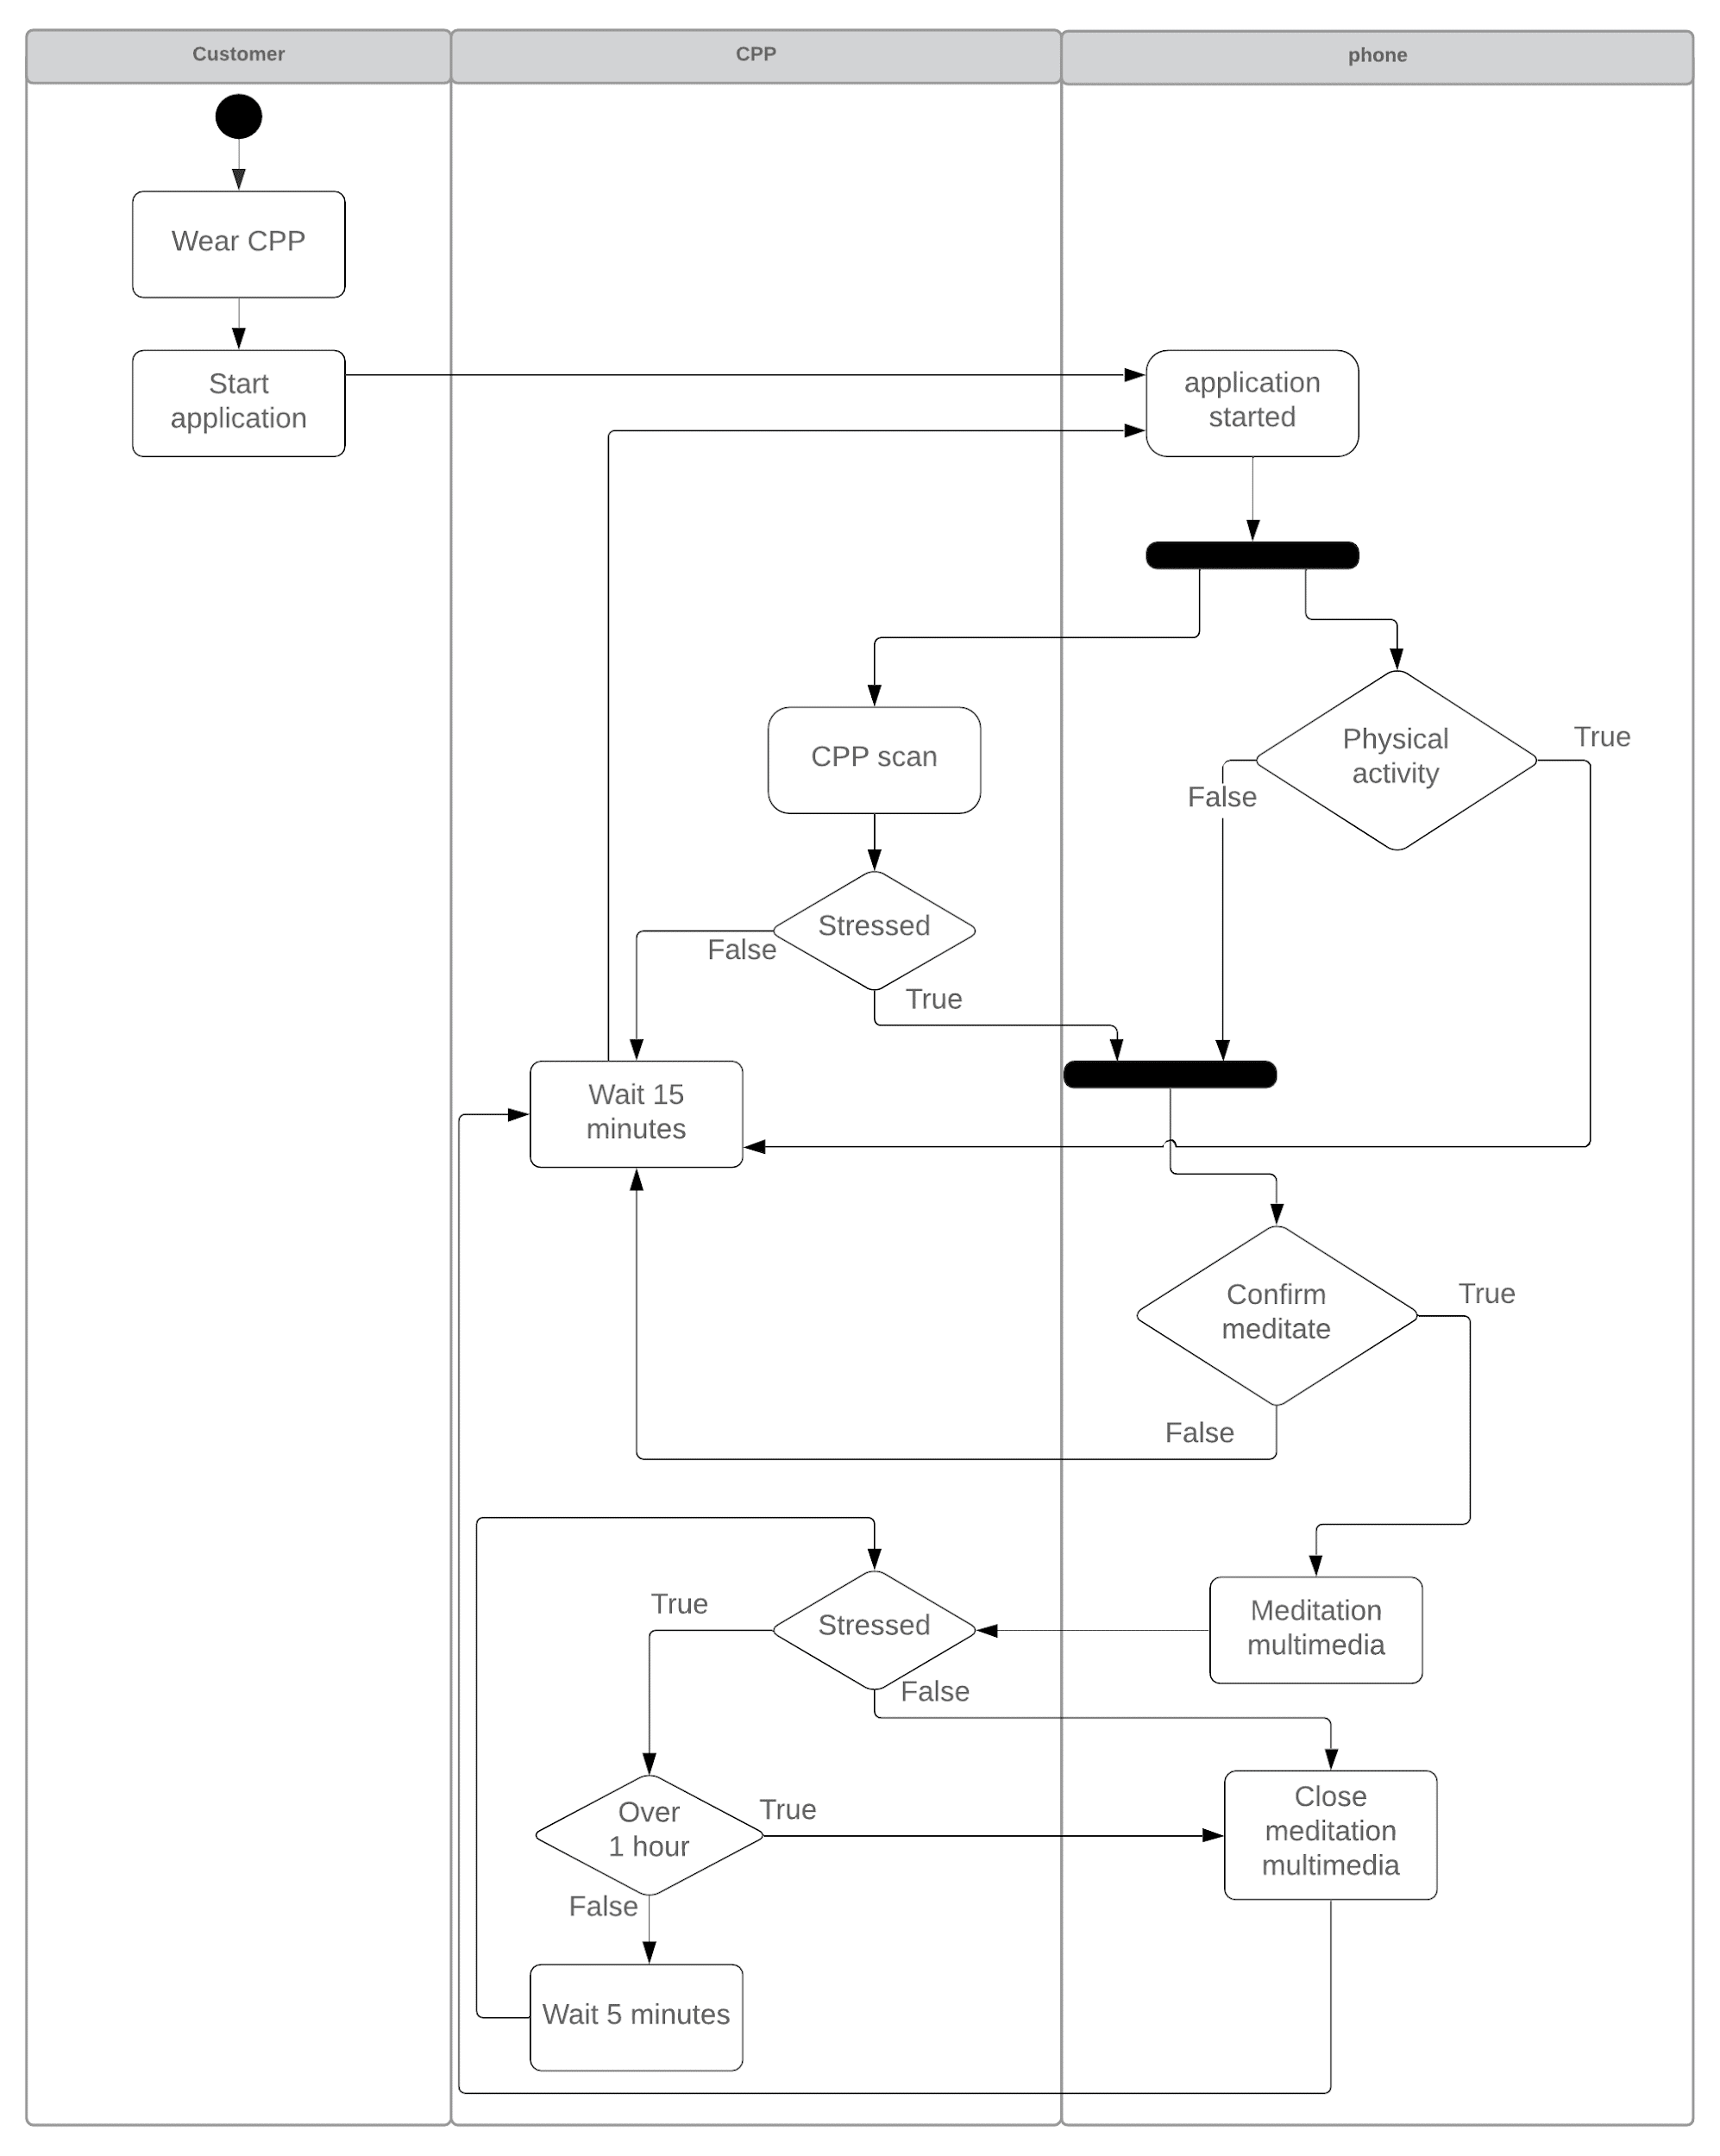

2.1

1. The petri is dead as there are no transitions that can be done at the moment (t1 needs p1 to have a token for it to be activated). It is also delimited as there are no transitions that can be done so p1 cannot get a token and p2 cannot get more than 1 token.
2. The petri is alive as t1 can always be activated as it needs 1 token from p1 and outputs a token to p2 and p1 (which can then be used to reactivate t1). It is not delimited as t1 takes 1 token and outputs 2, without any other transitions the number of tokens will go up. In this case p2 will get tokens as the cycles go on, p2 will get an infinite amount of tokens.

2.2

1. The petri is alive as t2 can always be activated. T2 needs a token from p3 and p4 which start with a token each, t2 can then be activated and will take both tokens and output 1 token into p4 and p4. Because p3 and p4 now have tokens they can reactivate t2 and restart the cycle. The system is also delimited as t2 takes 2 inputs and outputs 2, it takes one from p3 and one from p4 and then outputs one to p3 and one to p4. P3 and p4 can not have more than 1 token each, and p1 and p2 cannot have more than 0 tokens as t1 needs a token from p1 and p3 to activate but p1 cannot get a token and does not start with one.
2. The petri is not alive as if t1 is activated p2 will receive a token and p1 and p3 will lose their tokens. At that point t2 cannot be activated as it needs a p3 and p4 token but p3 does not have a token, t1 needs a p1 token but p1 does not have a token. The system is delimited as p3 and p4 cannot have more than 1 token each for the same reasons as 2.2 a). P1 and p2 also have delimits of 1 token each as p1 starts with a token and p2 can get 1 token from t1 which can only be activated once.
3. The petri is alive as if t1 is activated p2 and p3 will receive a token and p1 will lose its token. At that point t1 cannot be activated as it needs a p1 and p3 token but p1 does not have a token, t2 needs a p3 and p4 token t2 can then be activated and a token will be taken from p3 and p4, p3 and p4 will gain a token. The cycle can be repeated. The system is delimited as p3 and p4 cannot have more than 1 token each for the same reasons as 2.2 a). P1 and p2 also have delimits of 1 token each as p1 starts with a token and p2 can get 1 token from t1 which can only be activated once.

2.3

1. The petri is alive as there are no paths to kill it. It is also delimited to a max of 1 for each p.
2. The petri is dead as if you do t1 with an input from p1 and p3 and an output to p2, p3 and p4. Tokens will be found in p2, p3, p4, and p5. You can then activate t3 using p4 and p5. You will be left with 2 tokens in p3 and 1 token in p2. There are no longer any possible transitions that can be activated. It is also not delimited as p4 can continuously gain tokens if you cycle through t1 and t2 as each one of them adds a token to p4.

2.4

1. P4. P8 cannot activate t6 and p4 cannot activate t3. P3 activates t2 and goes to p2, it then activates t1 and goes to p1. P4 is now unblocked and can activate t3 with p1. And they both end up in p5. Now p8 is unlocked as p5 now has a token. They both activate t6 and a token goes to p9. P9 activates t7 and goes to p6. P6 activates t4 and goes to p7. P7 activates t5 and a token goes to p5 and one to p8. P8 and p5 can activate t6 and the cycle restarts.
2. P9. P1 can only activate t1 and gets blocked once it reaches p2 since t2 requires p5. P9 cannot activate t3 or t6 and so activates t9 and goes to p10, p10 cannot activates t4 or t7 and so activates t11 and goes to p12. P12 can only activate t12 and goes back to p9 only to redo the cycle.